**OBJECT TRACKING ROBOT ON RASPBERRY PI USING OPENCV**

**AIM:**

Automatic use of equipment, control systems and information technology to improve product in the production of goods and the delivery of services. Implementation of control systems and information technology to reduce the need for human activity in the production of goods and services. In the industrialization, automation is a step beyond the use of machinery. At the airport, the default cargo system is introduced many years ago that removed loads from entry points to flight belts but a the passenger needs to carry his luggage from the airport door to the airport entrance with the help of a standard luggage system. A standard luggage plan for both very nutritious and hard-working. At the same time it is an expensive and slow process. Auto-proposed

A carrier system can provide those features that are needed to overcome problems mentioned above. A real-time monitoring system that uses an automated system is introduced for proper verification movement following a Smartcard carrying a passenger. In the desired automation process system, a six-wheeled robot built. This Smartcard sends a signal to the tower. An The ultrasonic sensor is used in an automated system to hear the signal received by the sensor from tower where the triangular path takes place. That ultrasonic sensor detects the local range compatible Smartcard and user. After that the default system uses a person who follows the algorithm with the idea of ​​finding the exact position of the smart card user and following the user. The default program will do always keep a distance of 2mitre from the user in order to avoid conflicts with the user. Smartcard will be available in the user and passenger pocket at each airport before check-in. If there are two or automated systems dedicated to performing the same function on their smartcard owner, the appropriate signal acquired by the sensors of each robot with their smart card holder and this is done with the help of triangular path. The triangular method sends the appropriate signal to that particular ultrasonic sensor that already exists waiting to receive a signal on its Smartcard. The ultrasonic sensor is therefore dedicated to performance with only one

Smartcard. Both the Smart card and the ultrasonic sensor continuously send and receive the signal respectively. This default system is configured in such a way that it can detect the location of a restricted location such as laundry room; The hospital control room and the police inside the airport and keep them away from restricted areas.

In such cases there may be waiting rooms next to those types of rooms where the user can park their robots while using those secret locations. This automated system is also designed in such a way that it can hear any the kind of obstacles in front of you and judge them easily without colliding with obstacles. If there are any kind of obstacles in front of the default system depending on the conditions you are able to create takes another route to follow its Smartcard manager. This is the proposed freight plan designed here to fly smoothly to the airport. Airport must have one lounge and one waiting room in each restricted area so that the default system can gain power while their smartcard the handle is attached. If 20% of the case is left, the default system can return to the rest area and recover some ability to work again. When the user is finished, the user will store the smart card in the available card holder on the surface of a strong body. After that the default suggested system will return to the rest area.

**Hardware & Software Requirements:**

Raspberry Pi

Web Camera

Raspbian OS

Python

RPi.GPIO Python Library

OpenCV It (Open Source Computer Vision)

Numpy

Remote Desktop Protocol (RDP)

Servo motor

Wi-Fi dongle

**Project Flow**

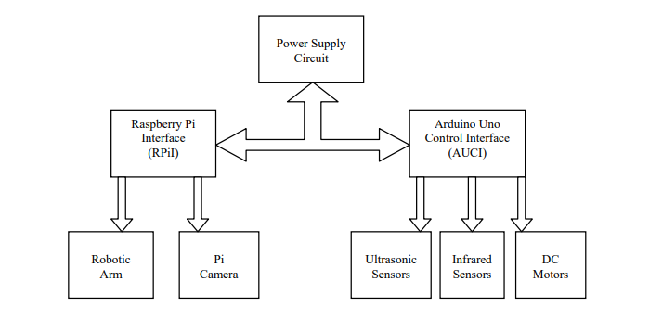

Camera

A Live video is captured from the webcam. The preprocessed frames are then converted to black and white, object is identified by finding the contours of the object and then, centroid of the object is calculated. Preprocessing of the frames include noise removal and conversion to grey scale. The frames are divided into virtual grids which help the robot to move to the object based on its centroid. Once the robot reaches the object and finds the object is stationary for few frames, it picks the object. The color of the picked object is analyzed and then the object is placed into its respective colored container.

**Proposed Model**

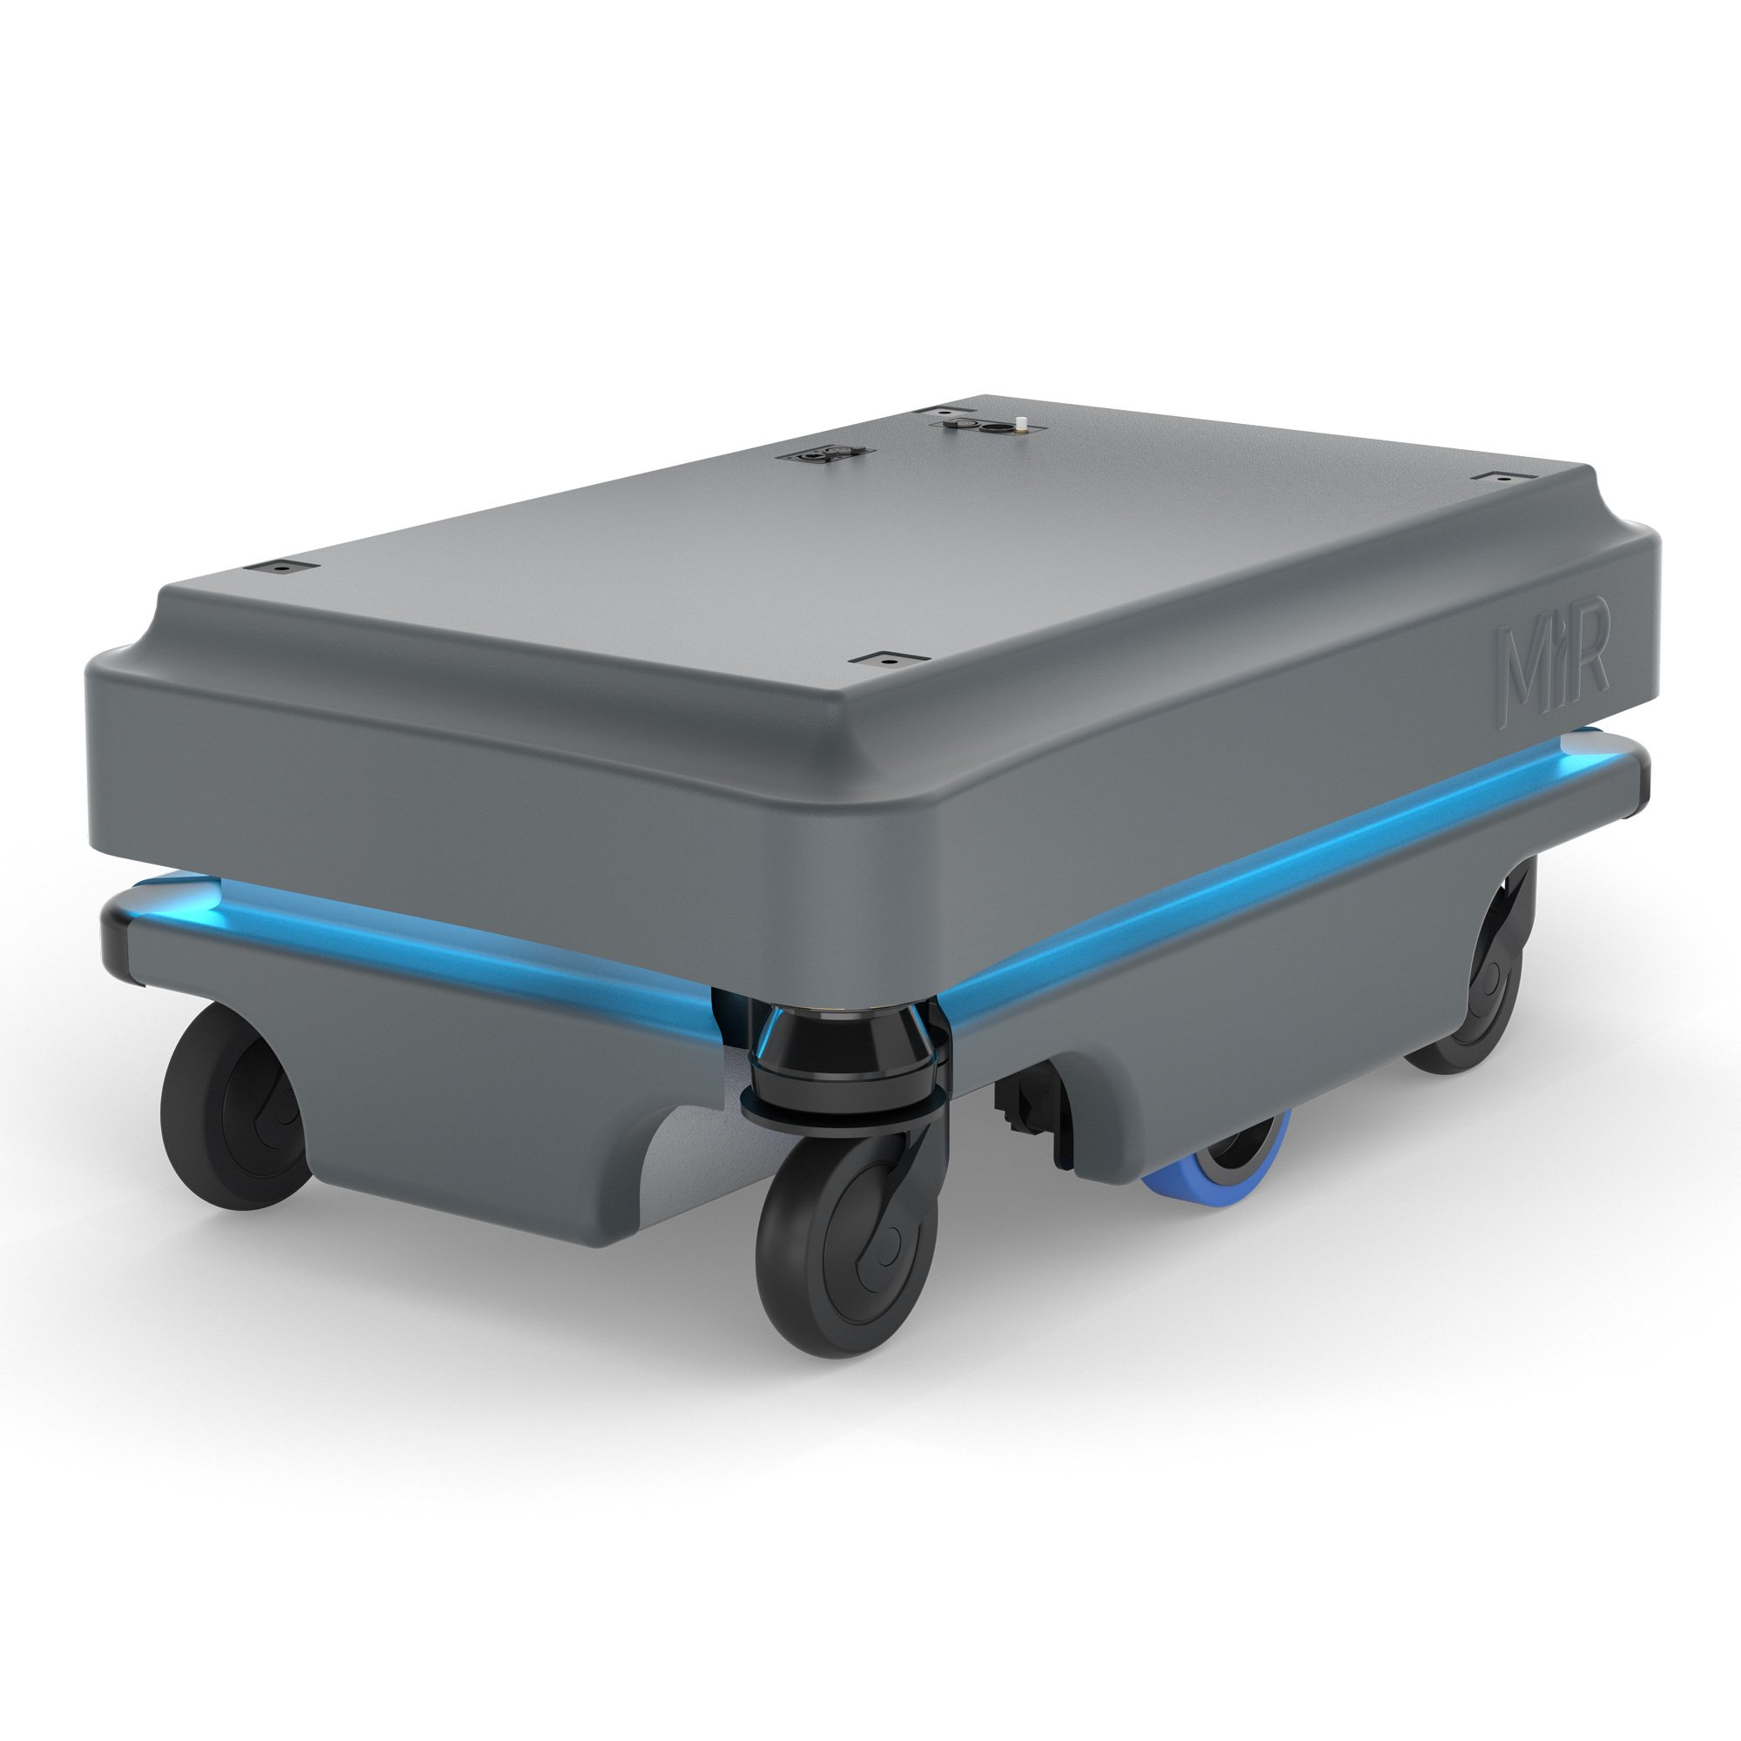

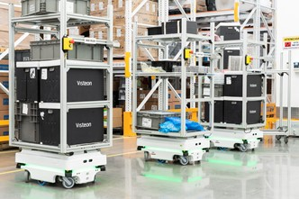

At the end of the automatic mode, robot tracks, analyses the colour of the picked object and drops the object into the respective colored container. At the end of manual mode, robot moves and does the task as desired by the user according to the commands given through the application (app).

**Stake Holders**

It would be easy on consumers to be free form carrying the language and since its completely automatic i.e. it picks and drops form source to destination. And moreover it saves time! Second thing these would be largely available only in those areas like airport, shopping malls, hotels, etc. As it would reduce the human activity for transportations.

In various industries they can take it to another level as it helps to transport high laguages without the help of the human.